**LAB SHEET - 06**

**Name : Ranudi Gayathmie Kariyapperuma**

**Index : 29897**

**Batch No : 23.1**

**Degree Program Name : Technology Management**

**Er diagram.**

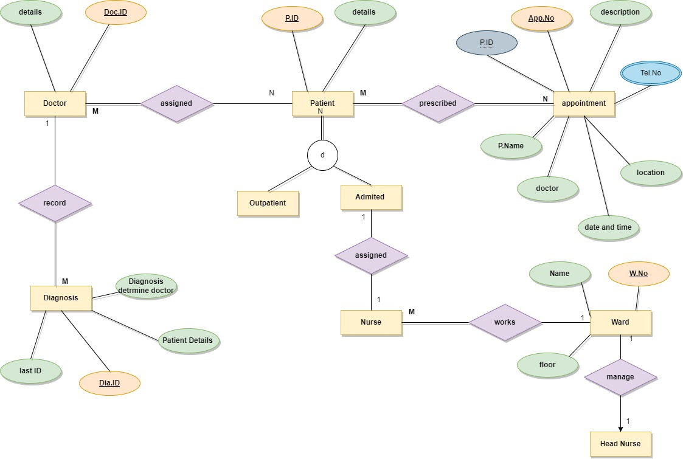

**Assumption**

* In this diagram doctor , patient and the diagnosis have a unique identifier that means a primary key.
* Patient has a disjoint with outpatient and admitted patient.
* In appointment entity it has a unique identifier it called as appointment name.